Weekly Diary

Week 1:

* Added a third triangle
* 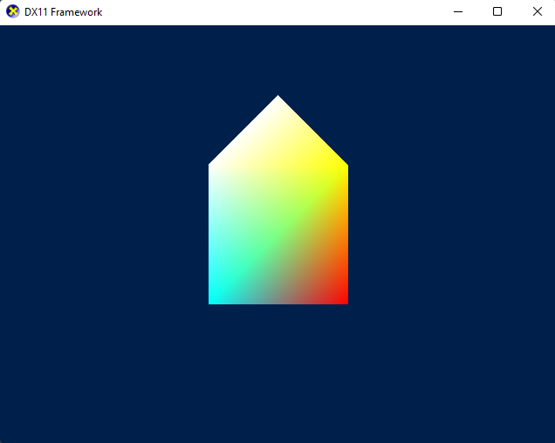
* Draw a spinning cube (normal were set wrong, had to be fixed)
* 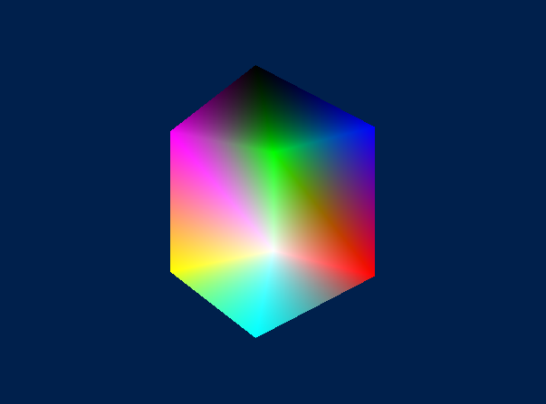

Week 2

* Made a solar system of multiple cubes orbiting each other
* 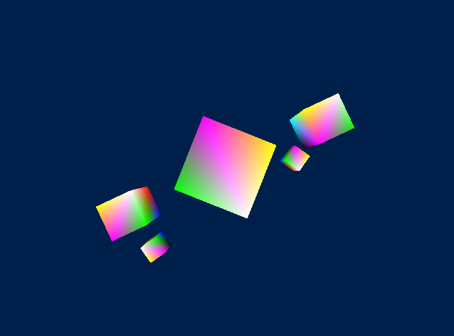
* Added feature to change view mode to wireframe
* 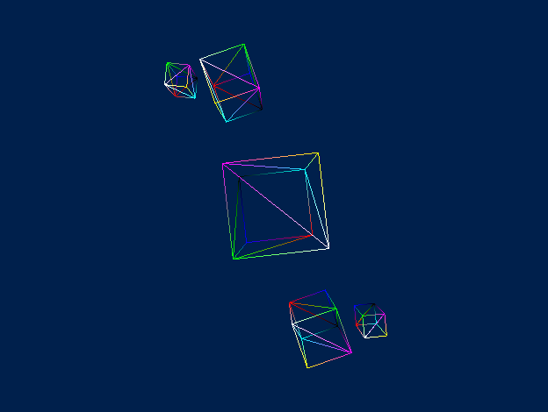
* Added vector3 class

Week 3

* Did shader manipulation
* Added pyramid mesh object
* Added matrix class (not working)

Week 4

* Fixed matrix class (from week 3)
* Made different meshes render at once
* 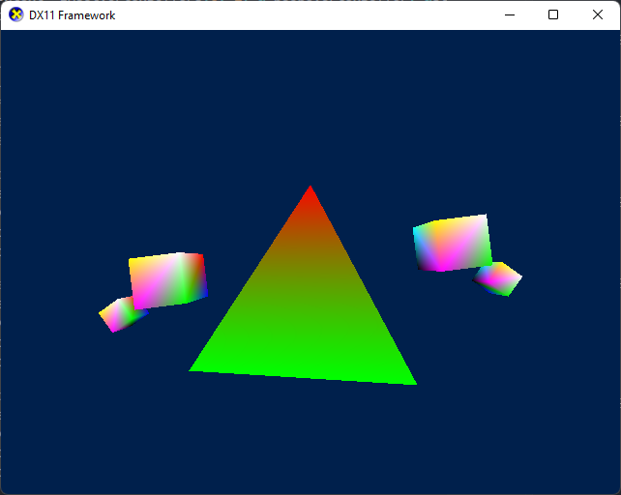
* Loaded normals by manually reading .obj file

Week 5

* Added diffuse and ambient lighting (some normals are still buggy)
* 